

**以笔之名 手写师恩——2019首届荆楚小书法家大赛**

**学校： 班级： 姓名：**

|  |  |  |  |  |  |  |  |  |  |  |  |  |  |  |  |
| --- | --- | --- | --- | --- | --- | --- | --- | --- | --- | --- | --- | --- | --- | --- | --- |
|  |  |  |  |  |  |  |  |  |  |  |  |  |  |  |  |
|  |  |  |  |  |  |  |  |  |  |  |  |  |  |  |  |
|  |  |  |  |  |  |  |  |  |  |  |  |  |  |  |  |
|  |  |  |  |  |  |  |  |  |  |  |  |  |  |  |  |
|  |  |  |  |  |  |  |  |  |  |  |  |  |  |  |  |
|  |  |  |  |  |  |  |  |  |  |  |  |  |  |  |  |
|  |  |  |  |  |  |  |  |  |  |  |  |  |  |  |  |
|  |  |  |  |  |  |  |  |  |  |  |  |  |  |  |  |
|  |  |  |  |  |  |  |  |  |  |  |  |  |  |  |  |
|  |  |  |  |  |  |  |  |  |  |  |  |  |  |  |  |
|  |  |  |  |  |  |  |  |  |  |  |  |  |  |  |  |
|  |  |  |  |  |  |  |  |  |  |  |  |  |  |  |  |

**作品要求：**

1. 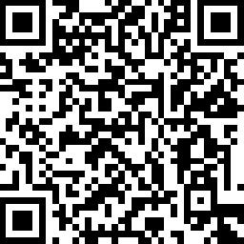作品以体现感恩老师的诗句或语言为主，须

为完整的段落或句义完整的句子。

1. 请统一用本卷进行书写并提交，可使用铅笔、

钢笔或黑色水性笔书写。 扫码上传作品